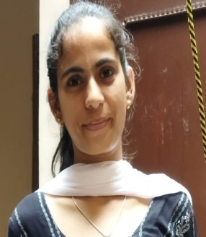 AAYNA CHEETU
Contact: +91 – 8278802884, 9816040738
E-Mail: aaynacheetu16@gmail.com
Very innovative, industrious, result oriented and fast grasping Post Graduate student willing to serve any area where my educational skill could be proved to achieve milestone in specific areas.

Objective:
Seeking an opportunity with a leading organization where my whole education and skill could be proved as one of the profit center. Willing to work with organization which appreciate and recognize my educational skills and performance for better career management.

Experience:Nil
Educational Qualifications:
ACADEMIC DETAILS
2013 10TH FROM PSEB MOHALI BY SECURING 87% MARKS
2015 12th FROM HPBSE DHARAMSHALA BY SECURING 75% MARKS
2018 B.Sc. (Chemistry Honors) FROM HPU SHIMLA BY SECURING 87% MARKS
2020 M.Sc. (Chemistry) FROM PU CHANDIGARH BY SECURING 86% MARKS
Complete B.Ed from HPU in session (2020-22), but still waiting for the results of final semester

STRENGTH
- HARD WORKER
- HONEST
- FAST LEARNER
- HIGH IQ LEVEL.
OTHER ACCOLADE
- Received Appreciation as Scholarship in 2013.
PERSONAL DETAILS
Date of Birth : 9thSEP, 1998
Father Name : Shri Raj Kumar Cheetu
Languages Known : English, Hindi and, Punjabi.
Permanent Address : P252/1, Jaral New Colony ,Pandoh District Mandi (HP)-175124

AAYNA CHEETU
PLACE: Mandi (HP)

